FBC Youth Summer 2019

This summer holds many different chances for you to gather with your friends from church to play and laugh and learn. I hope you remember the feeling of how great it was to spend time together at camp and on mission trip and at summer activities. You have so much to give to one another – friendship, encouragement and prayers, and your laughter. The school year and activities kept us all busy – and we weren’t able to be together as much - so I hope that you will make every opportunity to participate this summer when you are in town. Know that I am looking forward to seeing you this summer and – YOU are Loved!

Scott
---------------------------------------------------------------
JUNE:

9 – Youth and Parent Meeting – Church Fellowship Hall
17 – “Sticky Faith Summer” (SFS) – 12:00-2:30 pm – BYOL (Bring Your Own Lunch)
19 – Wednesday Night Supper and Activities – 5:15-7:30 pm – Kid’s VBS
27 – SFS – 12:00-2:30 pm – BYOL
30-July 4 – Mission Trip to Farmville, VA

JULY:

June 30-July 4 – Mission Trip to Farmville, VA
7 – SFS – 5:00-7:00 pm
11 – Ramp Building with Helping Hands Group – 7:30 am – 12:00 pm – Lunch provided after
15 – Baseball Game – Down East Wood Ducks – 6:00-11:00 pm - $5 plus it’s $1 hot dog night at
the park – Sign up by July 7.
17 - Wednesday Night Supper and Activities – 5:15-7:30 pm – Kid’s VBS
21-27 – Unidiversity Youth Camp – Maryville College – Maryville, TN

AUGUST:

1 – SFS - 12:00-2:30 pm – BYOL
5 – AirU Trampoline Park – 3:00-7:00 - $15 plus fast food $ - Sign up by June 29
11 – SFS – 5:00-7:00 pm
17 – Beach Trip with the Caseys – 8:00 am – 9:00 pm – Sign up by August 7
25 – SFS – 5:00-7:00 pm

SEPTEMBER:

7 – North Carolina FC Soccer Game in Raleigh – details to come
20-22 – CBF of NC Beach Retreat at Fort Caswell – details to come
Regular Youth Group Starts Back on September 15
More Info for You to Know!

Sunday, June 9th - 5:00pm
Youth and Parent Meeting at the Church
Info about summer activities – discussion about Mission Trip to Belize in 2020 – discussion of fundraising opportunities, etc.

Sunday morning Sunday School – 9:50-10:45 – I know Sunday mornings haven’t been a favorite time for many of you to be at church. It has been hard to have a youth SS class for 1 or 2 or 3 or no teenagers. So… we have been teaching the children in class on Sunday mornings. Thanks to you all who have been there and “helped”. I really would like for some of you to start helping teach. But I need to know when you will be there so I can give you something to help teach. Let’s talk more about this as the summer goes along.

Sticky Faith Summer – SFS – Yes, fun in the summer is a definite. And taking time to study God’s word and learn about God’s thoughts toward us is such an important thing to participate in this summer! I know – weird name – we will be studying through a book called Sticky Faith. We will be looking at some of the most important aspects of faith and following God and looking at some of the tougher questions in the Bible. The goal – to understand more about what God has to say and helping your faith to “stick”.

Wednesdays June 19 and July 17 – Mr. Glenn and I need your help as we have a program each of these nights with the children of our church. It will be in a VBS format – games, crafts songs and Bible stories. Please let me know as soon as you can if you can help out. Thanks!

---------------------------------------------------------------------------------

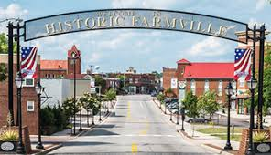

Mission Trip 2019 to Farmville, Virginia
June 30 – July 4 (Sunday-Thursday)
Cost is $70
YOU NEED TO LET ME KNOW WHETHER OR NOT YOU ARE GOING AS SOON AS POSSIBLE!

We will leave @ 3:00 pm on the 30th and be back home @ 4:00 pm on the 4^{th.}

Farmville is in south central Virginia – is filled with Civil War history – and is the home to Longwood University. We will be working through community service organizations to help residents of the community – minor home repair, painting, yardwork, possible food pantry, and possible work with children during our 3.5 days of work. We will leave on Sunday afternoon and return Thursday afternoon. We will be sleeping at the Baptist Student Center at the University (on the floor like last year). Once I know who is definitely attending, I will be able to finalize the work projects for our trip. Thanks!

---------------------------------------------------------------------------------

Unidiversity 2019 – “Fathoms”
July 21-27 (Sunday-Saturday)
Maryville College in Maryville, TN (just south of Knoxville)

Join us for a great week of learning, worship, fun and friendship! Proclaimer for the week is Amy Dean and Musician is John Callaway. Both are GREAT! www.unidiversity.org
Cost is $300. Deposit of $40 due by June 9. You will be able to sign up after this date, however registration with camp for students opens June 12. This is when you get signed up for the electives and seminar classes you want to take on a first come first served basis. List of elective and seminar choices are being sent to you separately. I need your choices no later than Tuesday the 11th you will have a better chance to receive your first choices on the 12th.
We will leave midafternoon on the 21st and return @ 5:00 pm on the 27th.

---------------------------------------------------------------------------------

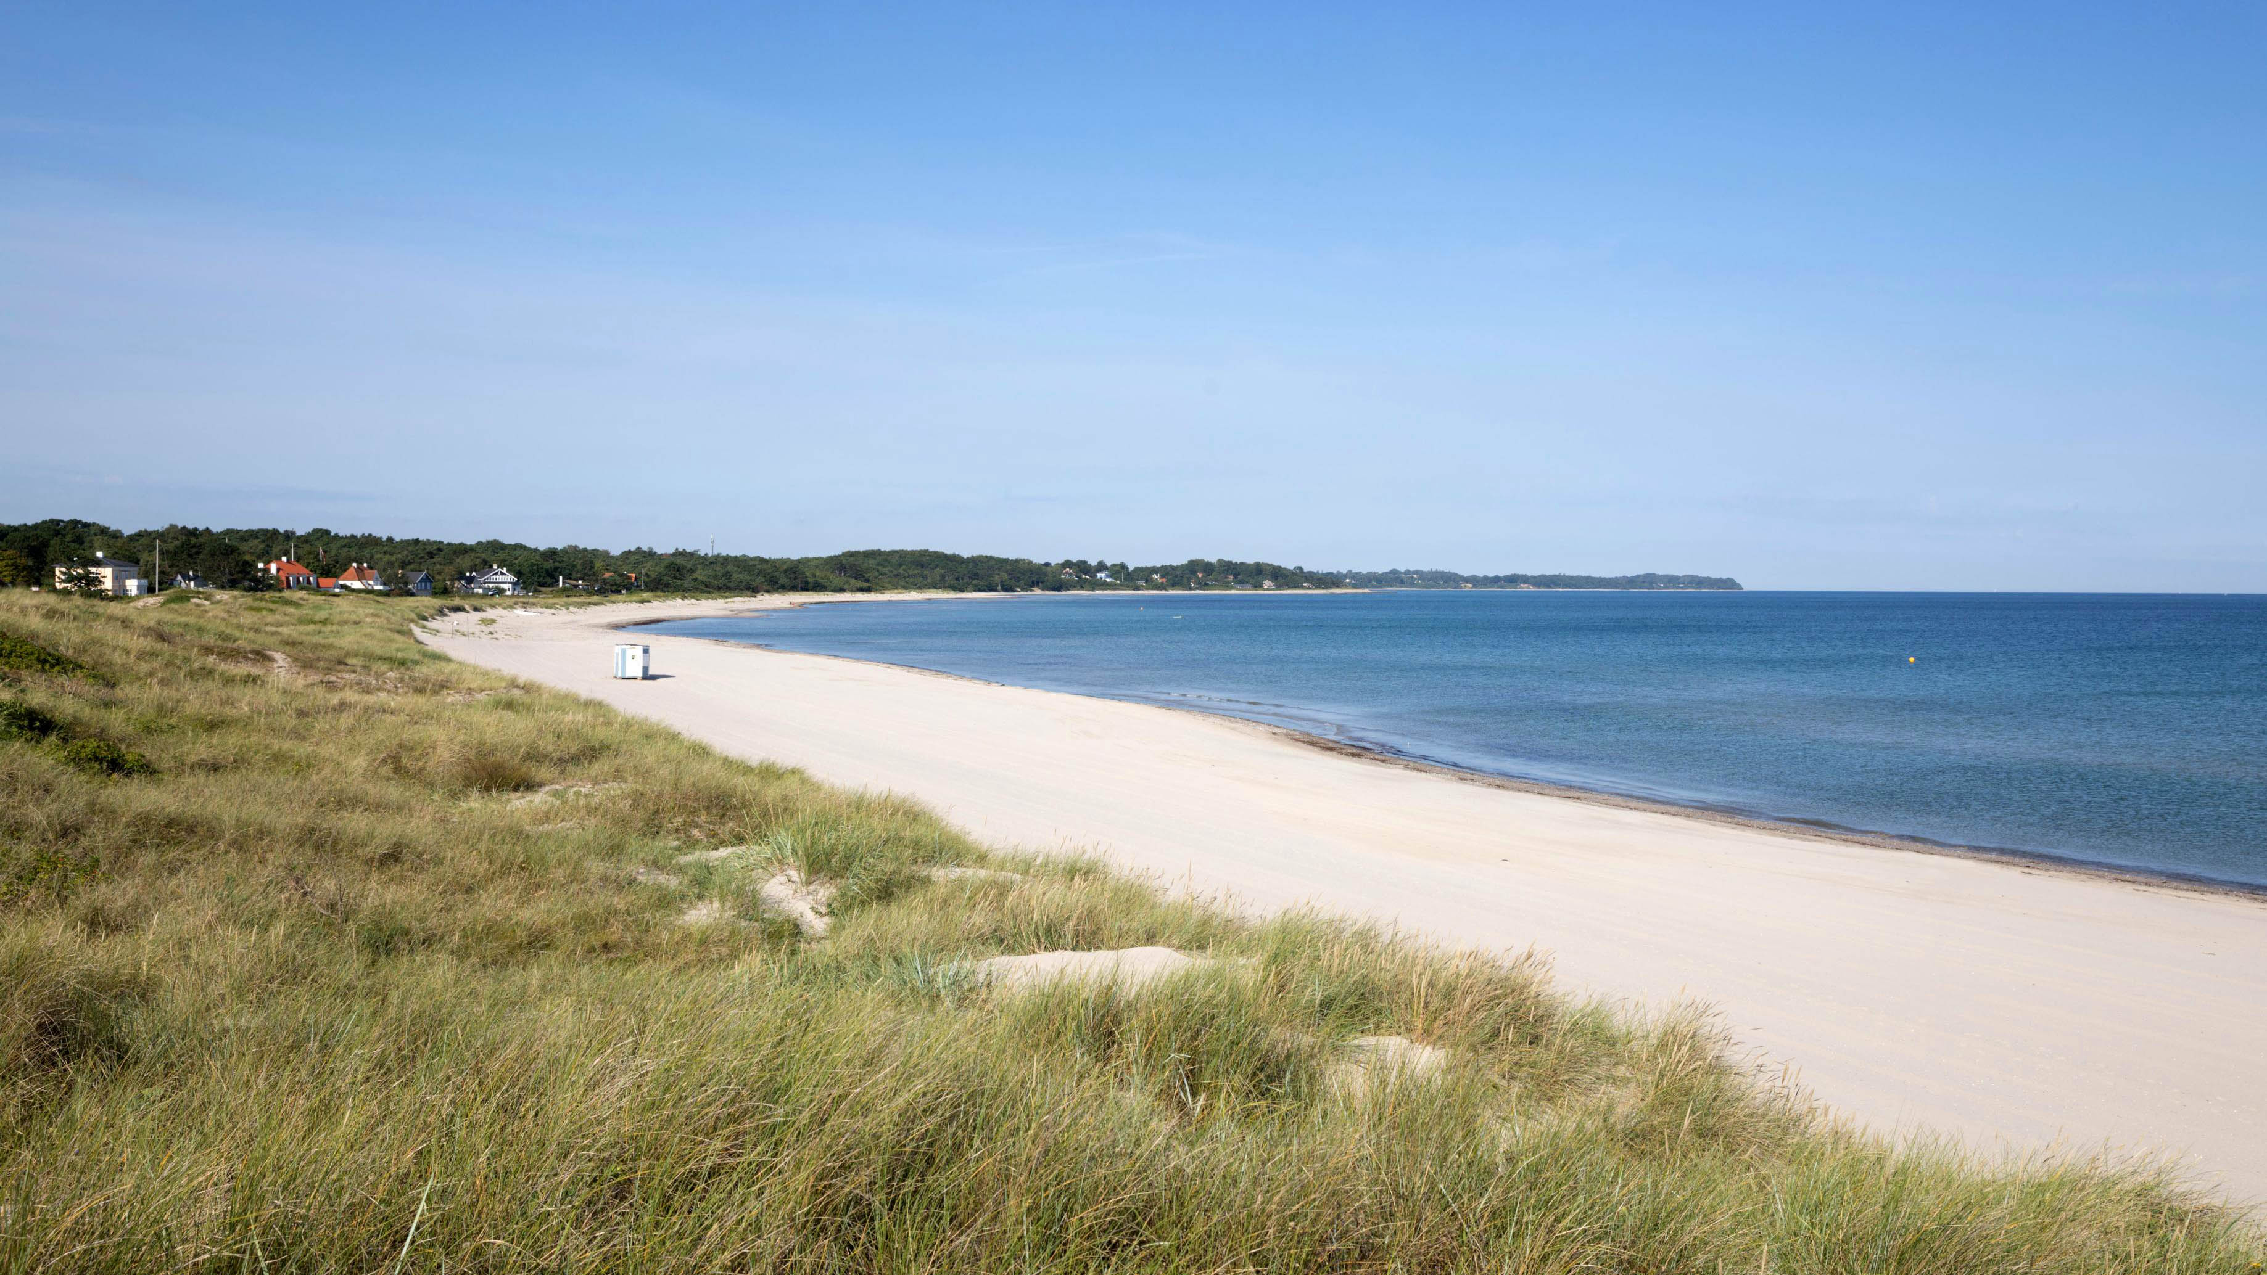

Beach Trip with the Caseys
Saturday, August 17

Word to parents about money:

PLEASE do not let costs keep your child from participating this summer. We have access to some limited scholarship funds. So please talk to me if you need to do so – confidentially of course. And if you need/want to pay some now and pay more later on during the summer or after the summer – we can certainly work that out. I apologize for not giving you more fundraising opportunities this year. So please let me help you out however I can.

